
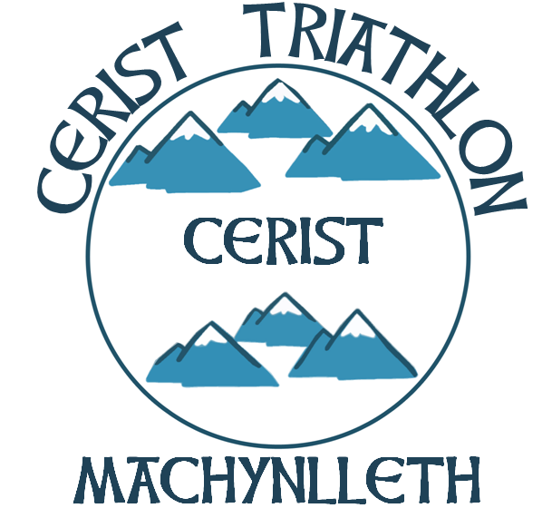
British Triathlon Volunteer Job Description

Volunteer Job Title | Volunteer Coordinator
Type of Volunteering | To act as Volunteer Coordinator on a Regional/Club level.
Main Purpose of Volunteering | To help implement British Triathlon’s Volunteer Support Strategy on a regional/club level and liaise with the National Volunteer Manager, race organisers and/or club members to address their volunteer needs.
Responsible to | The Regional/Club Chairperson.
Competencies / Experience required | Well organised, comfortable talking to various groups of people and have a basic knowledge of volunteering within Triathlon.
Commitment required | Time commitment will vary depending on time of year but on average, 8 hours per month.
Benefits to self | Contribution to creating a better structure for volunteers within Triathlon and simultaneously helping your region/club by recruiting more volunteers.
Benefits to community | A more structured volunteer system for your region/club and potentially more volunteers helping in Triathlon.
Support received from: | The Regional/Club Chair and the Regional Development Officer.
Is this Volunteer Opportunity open to disabled persons? | Yes.

